Title in Title Casing and Bold

Student’s First and Last Name
Department Name, School Name
Course Name
Instructor Name
Sept. 22, 2020

Abstract
An abstract is not indented. It is one paragraph and is typically between 150-250 words. The abstract page should be on a page by itself.
Keywords: Keyword are added at the end of the abstract and begin with Keywords: in italics. Commas go between all keywords.

Title in Title Casing: The Title is in Title Casing and Matches the Cover Page
The entire paper should have one-inch margins and each body paragraph should be indented using the tab key (1/2-inch tab). All spacing in the entire paper is double-spaced/evenly spaced in the text and headers.

Level One
The first level header should be centered and bolded. It will also have at least one paragraph listed. Header two is left aligned like below and has its own paragraph. Other headers are indented and begin like a paragraph.

Level Two
APA can include footnotes by selecting the text. Go to Home >Styles>Footnote Reference. They are not usually common and go on a page by themselves.

Level Three
Level three headers have a period after them. These are called run-in headings and can have a paragraph or several.

Level Four. Level four headers are in italics and in bold. They have a period after them. Don’t forget to cite your source as necessary in the text.

Tables
Table 1
Table Name
Column Name | Column Name | Column Name | Column Name | Column Name
Row Name | 100 | 200 | 300 | 400
Row Name | 500 | 600 | 700 | 800
Row Name | 900 | 100 | 200 | 300
Row Name | 400 | 500 | 600 | 700
Row Name | 800 | 900 | 100 | 200
Row Name | 300 | 400 | 500 | 600
Note: All tables should be on their own pages (one table on each page). They are numbered as: 1 2, 3, etc. as shown. The note is where you will explain the table. You can use the Styles gallery on the Home tab. Spacing inside the table should be 1.0 or 1.5. Most use 1.0 spacing. Headers should be set in the way shown. You can insert tabs by going to the Insert tab and table or you can copy/paste this one into different areas of the paper.

Figures
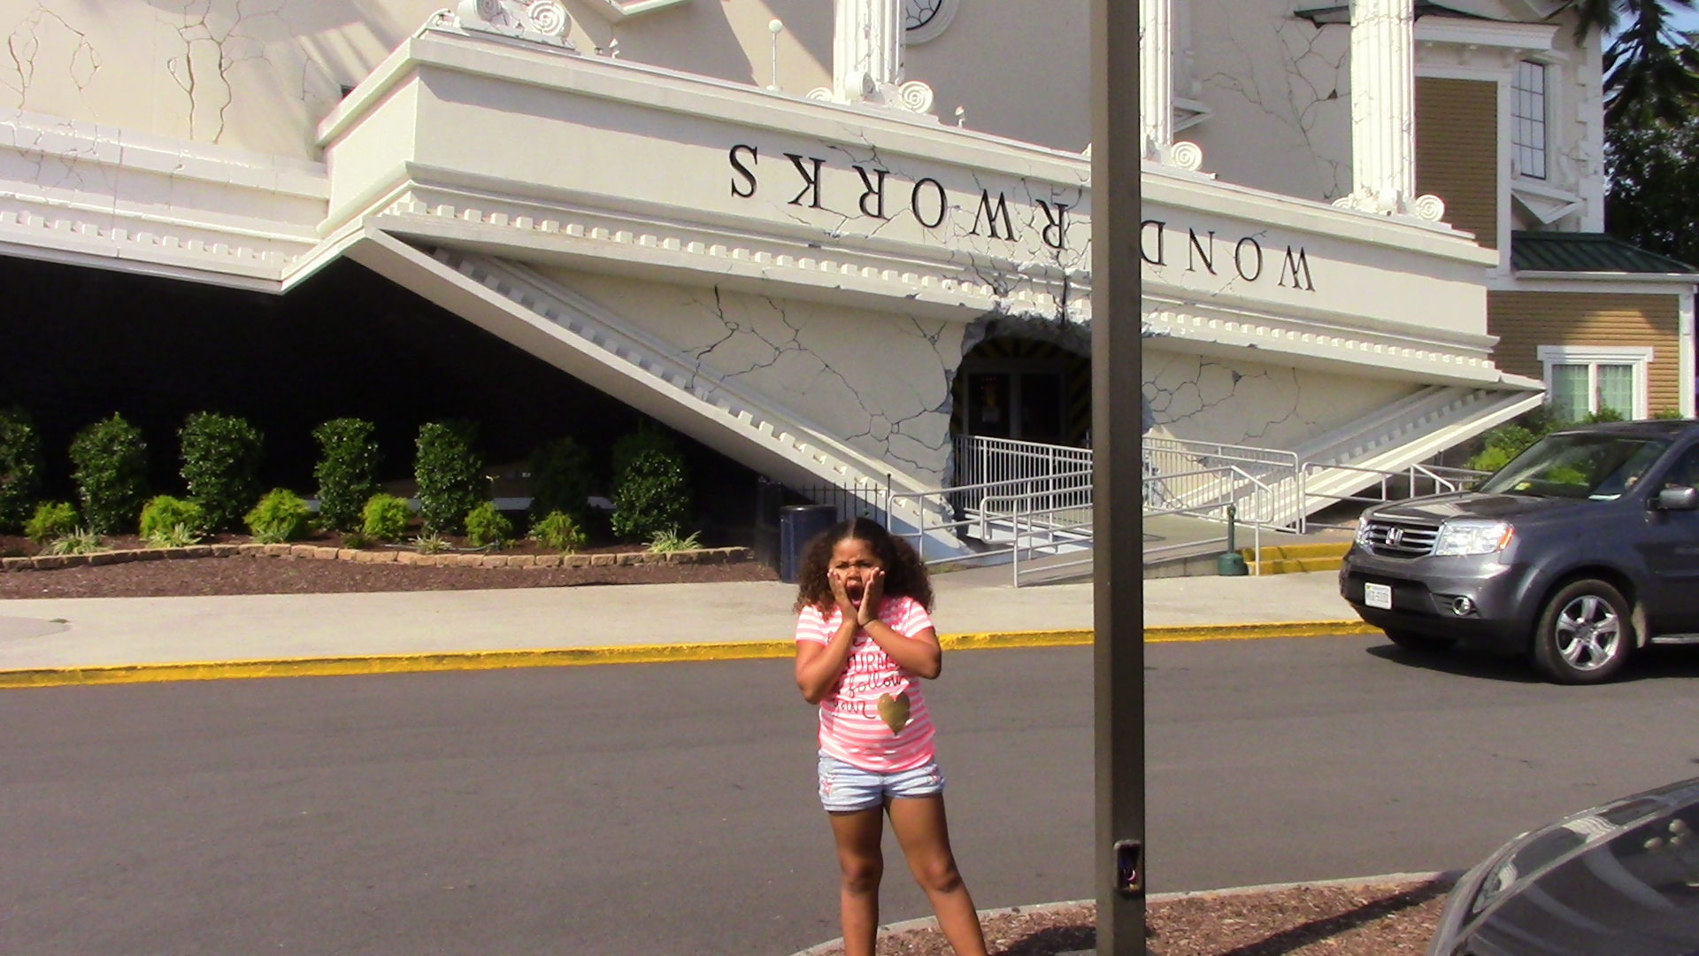
Figure 1: Figures go in a separate section with a numbered caption for each one such as 1, 2, 3, etc. as shown. To space the figure and caption correctly, it may be wise to use the Table (Figure) style.

References
References have a hanging indent. To properly cite your sources in APA, view the documentation style page. References are in alphabetical order.

